

**EE464 Project-2 Report**

Simulation and Design of the Hardware Project

Ekin Alp Biçer & Mert Elmas & Onur Külahlıoğlu

2089357

Table of Contents

1- Introduction 2

2-

2.1

2.2

3- Conclusion

# 1- Introduction

In this report, simulations and the detailed design analysis of the chosen topology for the hardware project which is the Forward Converter 3 is examined. Simulation part includes the design schematics of the ideal and the non-ideal cases and their input/output voltages and inductor/load currents. The simulations are to observe the differences caused by the non-idealities added to the ideal cases. Later, the design process and the parameters of the transformer such as core material, its geometry, the turns ratio and the operating flux density are revealed.Then, capacitor and the inductor selection is included as well as the efficiency calculation. Furthermore, the conclusion chapter culminates the chapters before and all the relationships that are explained.

# 2- Results

# Part-a *.*

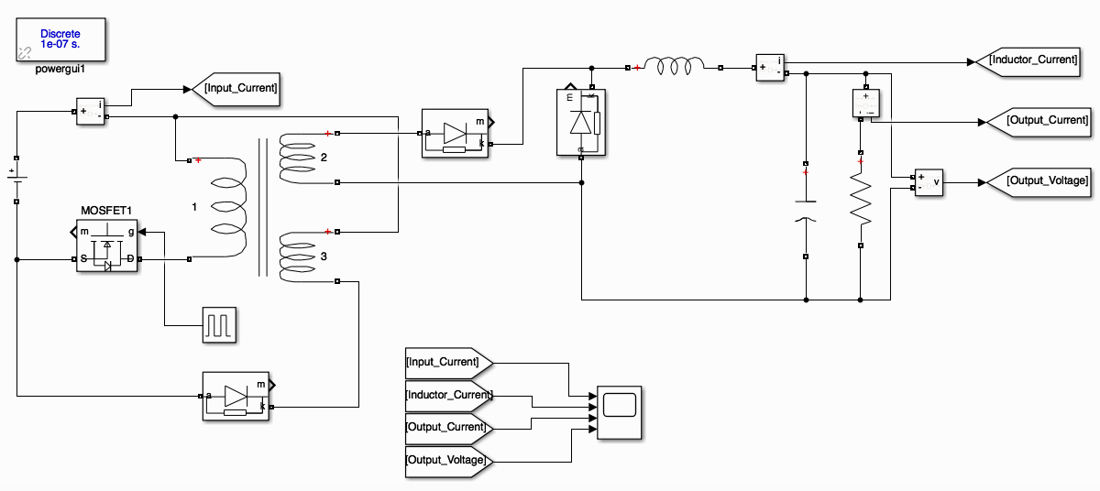

***Figure 1:*** *Schematics of the Forward converter design.*

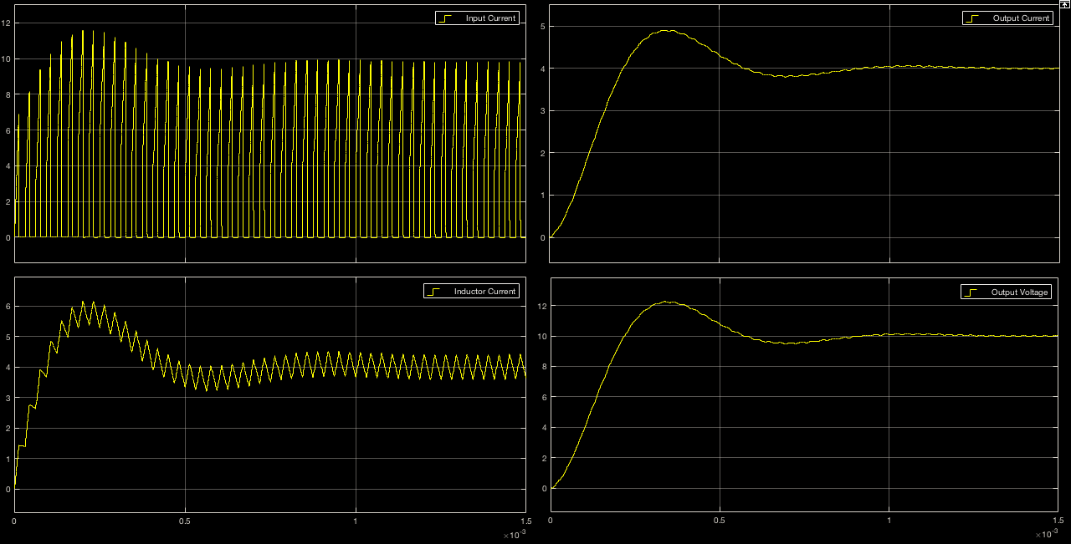

***Figure 2:*** *Graphs of the Forward converter design in the order of input current, inductor current output current and output voltage.*

From figure 2, it can be seen that the output is oscillatory which means the system is underdamped and as the time goes the system reaches its steady state where output voltage is 10V as desired (9.98-10.06). However it should be noted that the steady state is a sinusoidal voltage of 32kHz with a DC component. The envelope around the output is the one that dies out. Which is something to be expected since without AC the transformer would not work in the first place.

# Part-b

# Core selection

# Part-c

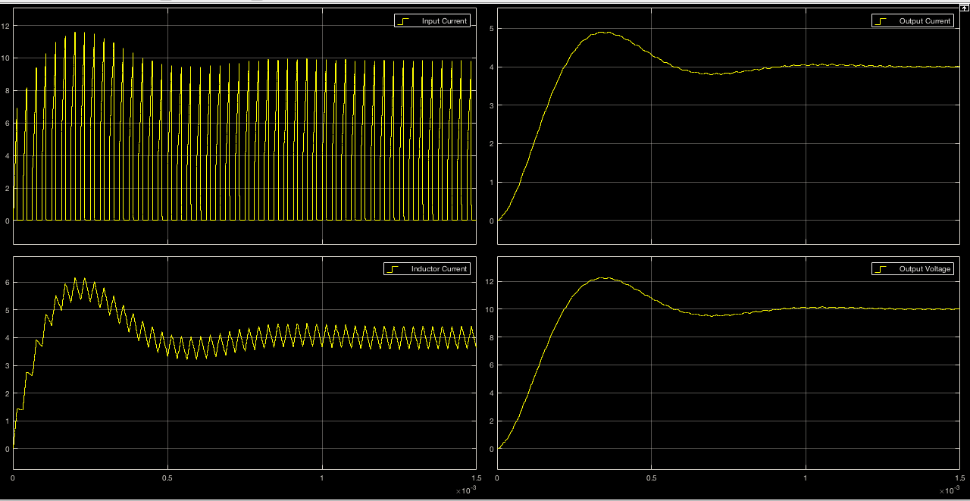

***Figure 3:*** *Graphs of the Forward converter design with ideal switch in the order of input current, inductor current output current and output voltage.*

# 

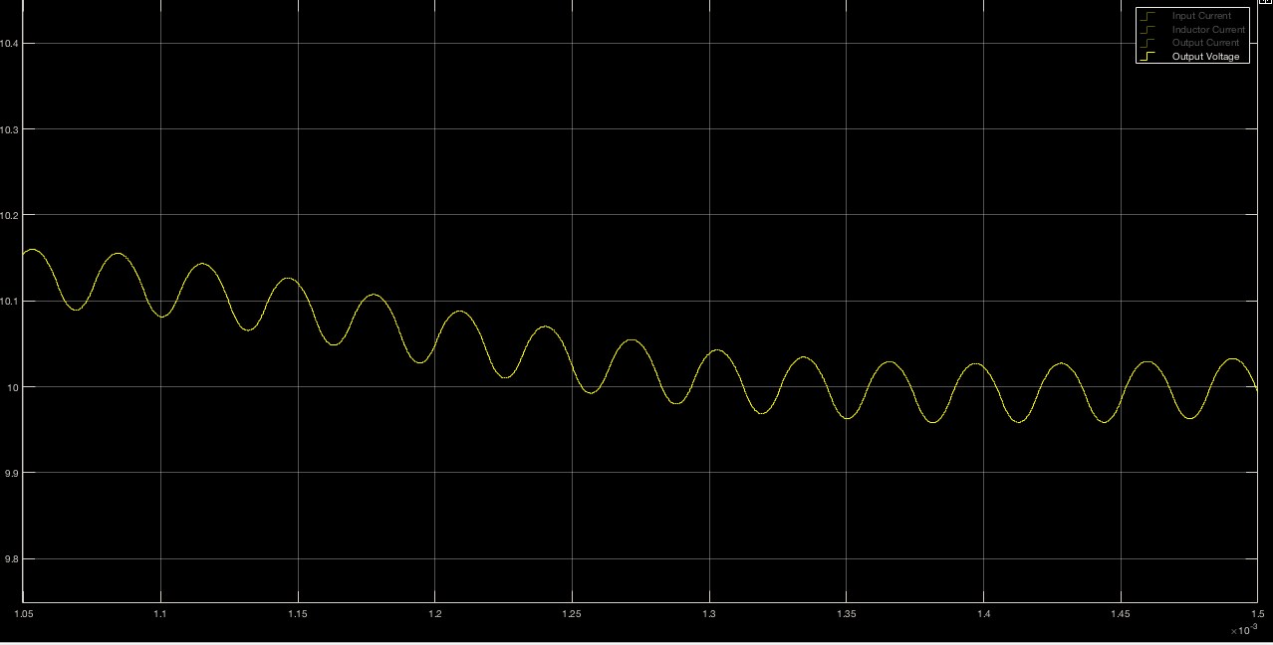***Figure 4:*** *Grapf of the output voltage ripple of the Forward converter with ideal switch .*

Part-d

# Part-e

# Part-f

# Part-g

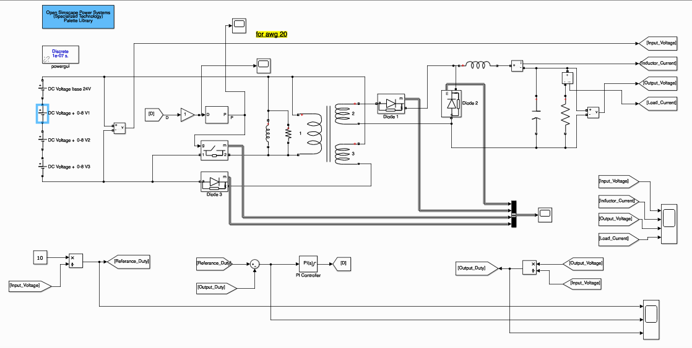

***Figure 4:*** *Schematics of the Forward converter design with the controller.*

Controller operation

The controller that we have designed is a PI controller that adjusts the duty cycle of the switch according to the input and output data which is the desired duty cycle ration coming from the input side as the reference signal and the actual duty cycle ratio coming from the output side as the feedback signal. The difference between them which is the error converges to zero as the PI controller works. In figure 2, the operation of the controller can be seen. As the input voltage increased 8 volts per step, the output does not change which can be seen in figure 5.

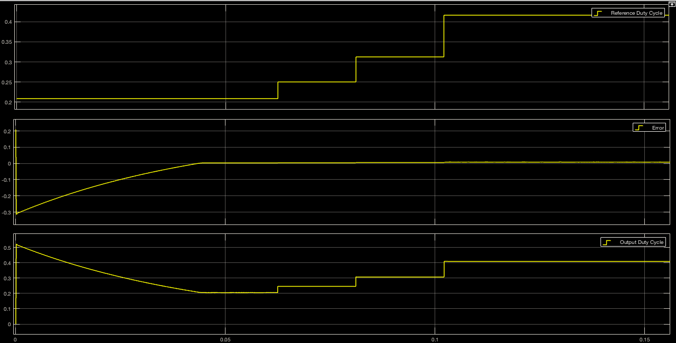

***Figure 5:*** *Graphs of the controller of the Forward converter design in the order of input duty ratio, error between input and output duty ratios and the output duty ratio.*

In figure 6, the effect of the input value change can be seen. First the converter reaches its steady state for the input of 24 volts. As the input voltage is increased by 8 volts in each time the output voltage is readjusted to its new value which is still around 10 volts. In figure 7, the ripples in the inductor current can be seen.

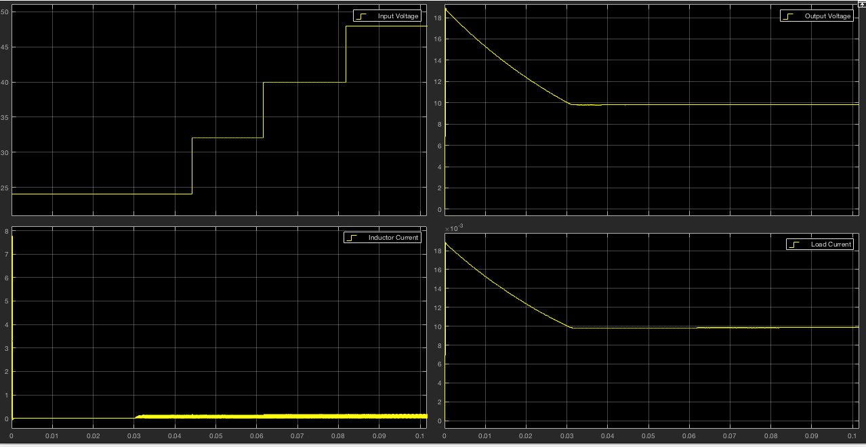

***Figure 6:*** *Graphs of the input/output voltages and inductor/load currents of the Forward converter.*

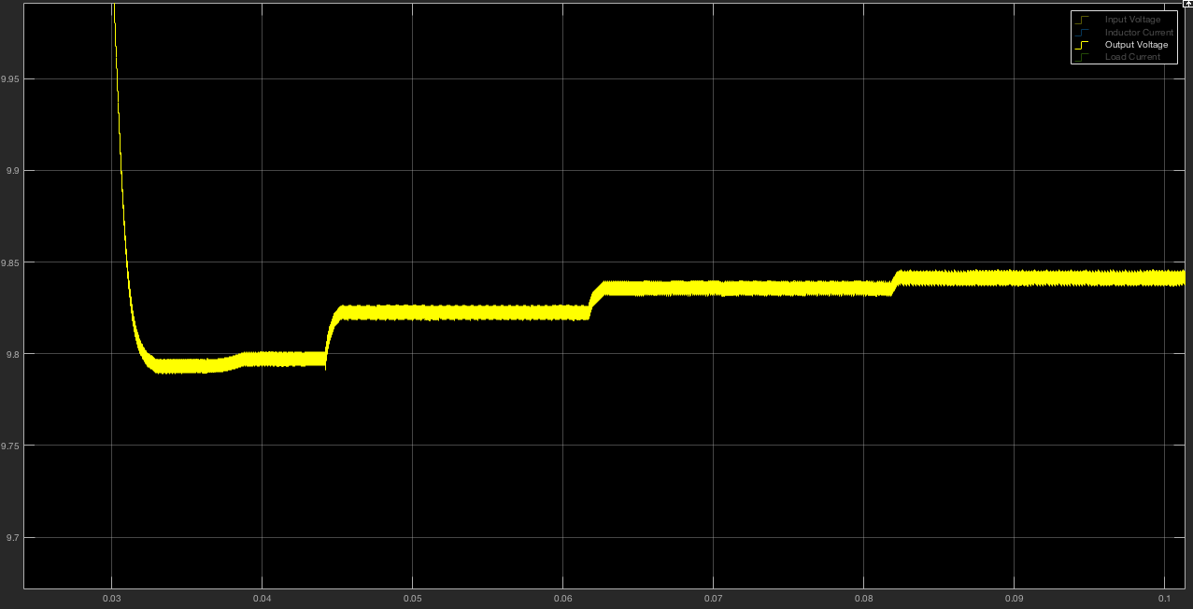

***Figure 7:*** *Graphs of the output voltage of the Forward converter.*

As it is evident from this graph, the steady state voltage ripple is less than 0.1 percent.

As another important fact is there is no oscillations in the outputs for the input changes. This could be related to the controller dynamics where the controller factors K and Ki creates damping to the system.

# 

# Part-h*.*

# 4- Conclusion